TitanTool Documentation

Overview
TitanTool is a Unity visual boss behavior graph tool that allows designers to create, validate, compile, and debug boss AI without writing code. It is demonstrated through a 2D boss fight prototype.
Features
- Visual boss behavior editor using Unity GraphToolkit
- Runtime behavior-tree execution through compiled BossGraphAsset assets
- Shared blackboard variables for boss state and gameplay data
- 2D prototype including player movement, shooting, bullets, prefabs, and URP2D

How titan tool works
Setup
Different Nodes
Keyboard shortcuts

How TitanTool Works
A TitanTool graph is a visual behavior plan for a boss.
Execution always starts at the Start Node, then follows graph connections through nodes that decide, move, wait, attack, spawn objects, or check conditions.
Most nodes belong to one of these categories:
- Flow Nodes – Define execution flow.
- Composite Nodes – Control which child nodes execute.
- Decorator Nodes – Modify the execution of a child.
- Condition Nodes – Check whether something is true.
- Action Nodes – Perform gameplay actions.
- Blackboard Nodes – Read or modify shared variables.
- Utility Nodes – Improve graph readability.
The core idea is simple:
- Composites organize behavior.
- Conditions decide what can happen.
- Actions perform the visible gameplay.
- Blackboard variables allow nodes to share information.

Setup
1. Configure the Boss
Add a Boss Director component to the boss and assign:
- Sprite Renderer
- Animator
- Player Transform
Also add a Boss Health component and configure its health values. Phase nodes use this component during graph execution.
2. Create Target Points
Target points define reusable positions for movement, spawning, and teleporting.
- Place Target Transforms in the scene.
- Press Use Scene Points on the Boss Director.
- Press Create Missing Target Point Keys.
TitanTool creates reusable Target Point assets inside:
Data/TitanTool/TargetPoints
These assets can now be referenced throughout the graph.

3. Create a Graph
Assign an existing graph to the Boss Director.
If none exists:
- Press Make New Graph
A new graph asset is created under:
Data/TitanTool/...
Finally press Open Graph to begin editing.

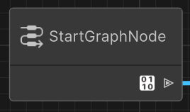
Start
Entry point of every graph. Every graph should have one Start node.
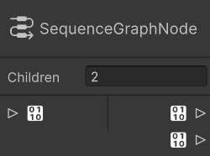
Sequence (Run In Order)
Runs children from top to bottom. Stops when a child fails.

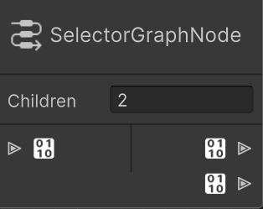
Selector
Runs children until one succeeds. Useful for choosing between phases or attacks.

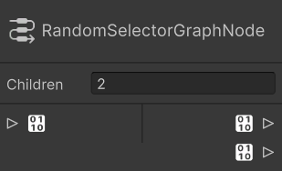
Random Selector
Randomly chooses one child to run.

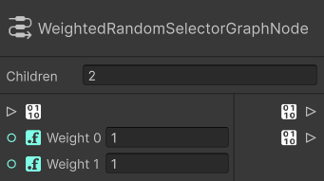
Weighted Random
Randomly chooses a child using weights.
Weight (Float)

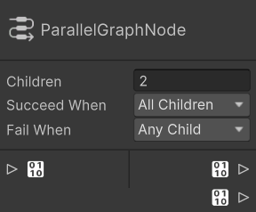
Parallel
Runs all children simultaneously.
Succeed When (All Children / Any Child)
Fail When (All Children / Any Child)

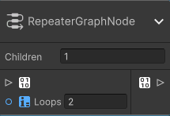
Repeater
Repeats all children a number of times.
Loops (Int)

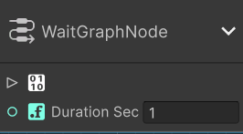
Wait
Pauses graph execution.
Duration (Float - Seconds)
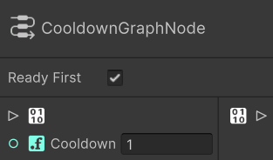
Cooldown
Allows its child to execute only after a cooldown.
Cooldown (Float - Seconds)
Ready First (Bool)
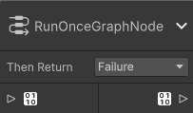
Run Once
Executes its child a single time.
Return After Run (Success / Failure)

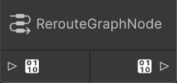
Reroute
Organizational node used to keep graphs clean.
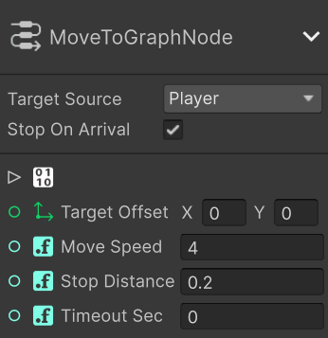
Move To
Moves the boss toward a target.
Target Source (Player / Boss / Fixed Position / Target Point) Target Offset (Vector2)
Move Speed (Float)
Stop Distance (Float)
Stop On Arrival (Bool)
Timeout (Float - Seconds)

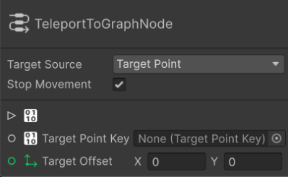
Teleport To
Instantly moves the boss to a location.
Target Source (Player / Boss / Fixed Position / Target Point) Fixed Position (Vector2)
Target Point (Target Point Key)
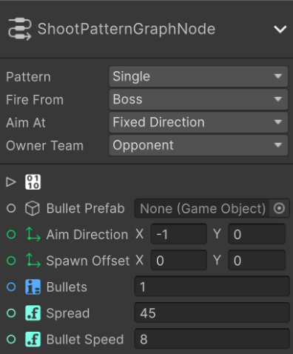
Shoot Pattern
Fires bullets in a predefined pattern.
Pattern (Single / Spread / Circle / Aim At Player)
Fire From (Boss / Player / Fixed Position / Target Point)
Aim At (Fixed Direction / Player / Boss / Player Snapshot)
Bullet Prefab (GameObject)

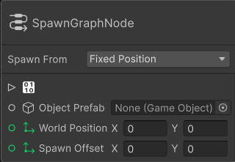
Spawn
Spawns an object.
Spawn From (Boss / Player / Fixed Position / Target Point) Prefab (GameObject)
Spawn Offset (Vector2)
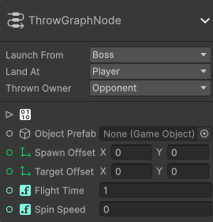
Throw
Launches an object toward a target.
Spawn From (Boss / Player / Fixed Position / Target Point)
Prefab (GameObject)
Spawn Offset (Vector2)
Target Offset (Vector2)
Flight Time (Float)
Spin Speed (Float)

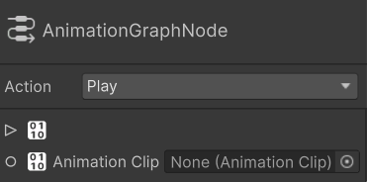
Animation
Controls the boss Animator.
Mode (Play Clip / Trigger / Set Bool / Set Float / Set Int / Cross Fade) Animation Clip (AnimationClip) Trigger (String) Bool (String) Float (String + Float) Int (String + Int) Cross Fade Duration (Float)
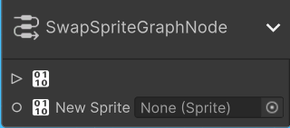
Swap Sprite
Changes the boss sprite.
Sprite (Sprite)
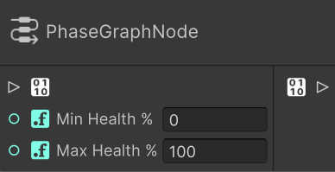
Phase
Checks whether the boss health is within a range.
Minimum Health % (Float)
Maximum Health % (Float)
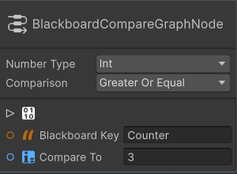
Blackboard Compare
Compares a Blackboard value.
Type (Int / Float)
Blackboard Key (String)
Comparison (== / != / < / > / ≤ / ≥)
Value (Int / Float)
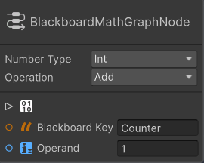
Blackboard Math
Performs math on a Blackboard variable.
Operation (Set / Add / Subtract / Multiply / Divide) Type (Int / Float)
Blackboard Key (String)
Operand (Int / Float)

Random Constant
Generates a random value.
Type (Int / Float) • Minimum (Int / Float) • Maximum (Int / Float)

